D

Explain how non disjunction leads to aneuploidy

Name some physical mutagens.

Describe the structure of DNA.

|  |  |
| --- | --- |
| **Term** | **Definition** |
| Allele |  |
| Dominant |  |
| Recessive |  |
| Phenotype |  |
| Genotype |  |
| Homozygous |  |
| Heterozygous |  |

Describe how inherited mutations can alter the variations in the genotype of offspring.

Explain the role of helicase in the process of DNA replication.

Describe the direction of replication during DNA replication.

What is a mutagen?

Outline the process of spermatogenesis

How does DNA occur in prokaryotic cells?

How does meiosis generate variation?

Outline the process of transcription.

________________________ is the mechanism by which the base sequence of a gene on a DNA strand is converted into the complementary base sequence of mRNA.

How many bases make a codon?

Draw and label a diagram of a nucleotide.

Define the term gene.

Define the term genome.

A large number of chemical mutagens are ___________and interact directly with DNA.

The name of the proteins that DNA is bound to in chromosomes.

Why is the term *junk DNA* misleading?

Explain the role of DNA polymerase in the process of DNA replication.

Explain how the process of random fertilisation and independent assortment alter the variations in the genotype of offspring.

Outline the process of oogenesis

Describe point and frameshift mutations.

Describe sex-linked inheritance.

Define polygenic inheritance.

How does DNA occur in eukaryotic cells?

The type of bond produced between amino acids in translation.

___________________ by ribosomes allows assembly of amino acids into polypeptides according to the original DNA code.

Outline what happens in each stage of meiosis:

|  |  |
| --- | --- |
| **Term** | **Key points** |
| Prophase I |  |
| Metaphase I |  |
| Anaphase I |  |
| Telophase I |  |
| Prophase II |  |
| Metaphase II |  |
| Anaphase II |  |
| Telophase II |  |

U4, T1 Revision



Noncoding DNA can make a variety of transcribed proteins, including:



Type of inheritance in haemophilia.

Type of inheritance in colour blindness.

Describe the process of making recombinant DNA.

Describe how mutations in genes and chromosomes can result from errors in DNA replication.

An example of a transcription factor gene that regulates morphology.

Two applications of DNA sequencing.

What are introns?

What are exons?

Differential gene expression, controlled by _____________________ factors, regulates cell differentiation for tissue formation and _____________.

Outline the process of translation.

Explain how the phenotypic expression of genes can be affected via environmental exposure.

Explain how the phenotypic expression of genes can be affected during the products of other genes.

Describe how mutations in genes and chromosomes can result from damage by mutagens (UV radiation, ionising radiation, heat and chemical).

Explain how the phenotypic expression of gene can be affected during transcription and translation.

Describe how mutations in genes and chromosomes can result from errors in cell division.



Identify the sex and genetic condition from the following karyotype.

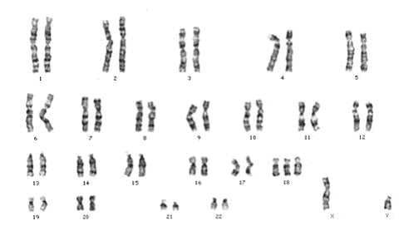

What is multiple allele inheritance?

An example of a transcription factor gene that regulates cell differentiation.

Type of inheritance in wheat grain colour.