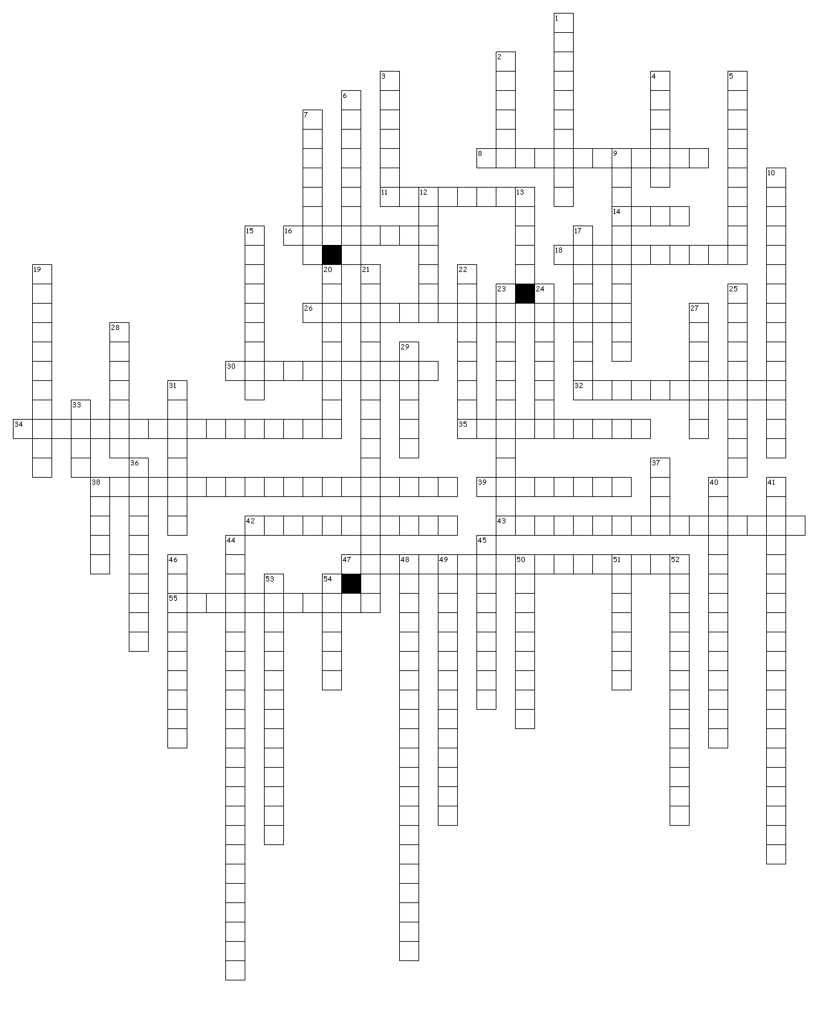

**UNIT 4 REVISION**

**Across**

8. the drifting of the frequency of alleles relative to that of other alleles in a population over time as a result of a chance or random event

11. any chromosome that is not a sex chromosome

14. a segment of a DNA or RNA molecule containing information coding for a protein or peptide sequence

16. the condition of having a diploid chromosome complement in which one chromosome lacks its homologous partner

18. the region of a chromosome to which the microtubules of the spindle attach, via the kinetochore, during cell division

26. the similar development of a trait in distinct species that are not closely related, but share a similar original trait in response to similar evolutionary pressure.

30. type of phenotypic selection where the most common phenotype in the population is selected for and continues to dominate in future generations.

32. type of sugar in DNA

34. speciation and macroevolutionary changes result from an accumulation of these changes over time

35. populations with reduced genetic diversity face an increased risk of this

38. the process in which organisms that are not closely related independently evolve similar features

39. translation of mRNA into amino acid sequences occurs here

42. second stage of protein synthesis

43. this occurs when the pressures of environmental selection confer a selective advantage on a specific phenotype to enhance its survival (viability) and reproduction (fecundity)

47. the accumulation of differences between closely related populations within a species, leading to speciation.

55. these enzymes cut DNA at specific points

**Down**

1. relating to or arising from non-genetic influences on gene expression

2. all the genetic material in the chromosomes of an organism, including its genes and DNA sequences

3. the first (primary) transcript from a protein coding gene that contains both introns and exons

4. RNA base that replaces thymine

5. type of phenotypic selection where extreme values for a trait are favoured over intermediate values and the population is divided into two distinct groups.

6. a sequence of three nucleotides forming a unit of genetic code in a transfer RNA molecule, corresponding to a complementary codon in mRNA

7. the movement and exchange of genes or alleles from one population of species to another

9. type of phenotypic selection where an extreme phenotype is favoured over other phenotypes, causing the allele frequency to shift over time in the direction of that phenotype.

10. the frequency of an allele relative to that of other alleles of the same gene in a population

12. base that pairs with adenine

13. coding genes

15. the ability to produce an abundance of offspring or new growth

17. a trait in which a gene is located on a sex chromosome. In humans, the term generally refers to traits that are influenced by genes on the X chromosome

19. when two or more species reciprocally affect each other's evolution through the process of natural selection.

20. another word for survival

21. a mutation caused by the addition or deletion of a base pair or base pairs in the DNA of a gene resulting in the translation of the genetic code in an unnatural reading frame from the position of the mutation to the end of the gene

22. the set of observable characteristics of an individual resulting from the interaction of its genotype with the environment

23. a mutation affecting only one or very few nucleotides in a gene sequence

24. this is the ultimate source of genetic variation, as it introduces new alleles to a population

25. HOX transcription factor families regulate this

27. base that pairs with cytosine

28. an agent, such as radiation or a chemical substance, which causes genetic mutation

29. a segment of a DNA or RNA molecule which does not code for proteins and interrupts the sequence of genes

31. a compound structure at the end of a chromosome

33. a type of RNA molecule that helps decode an mRNA sequence into a protein

36. the condition of having an abnormal number of chromosomes in a haploid set

37. region/s of DNA that are made up of nucleotides; the molecular unit of heredity

38. a sequence of three nucleotides which together form a unit of genetic code in a DNA or RNA molecule

40. the variation of allele frequencies at or above the level of species over geological time, resulting in the divergence of taxonomic groups, in which the descendant is in a different taxonomic group to the ancestor

41. a double-stranded molecule that occurs bound to proteins (histones) in chromosomes in the nucleus

44. the amplification of recombinant DNA

45. this enzyme binds sticky ends of DNA together

46. speciation that occurs when new species evolve in contiguous, yet spatially segregated habitats. Individuals maintain a zone of contact and do not cease the exchange of genes completely.

48. this refers to an increase in taxonomic diversity or morphological disparity

49. the purpose of this to synthesise a functional gene product (protein or functional RNA); that the process can be regulated and is used by all known life

50. change in the genetic composition of a population during successive generations, which may result in the development of new species

51. a condition in which an extra copy of a chromosome is present in the cell nuclei, causing developmental abnormalities

52. this can lead to aneuploidy

53. small-scale variation of allele frequencies within a species or population, in which the descendant is of the same taxonomic group as the ancestor

54. type of sugar in RNA

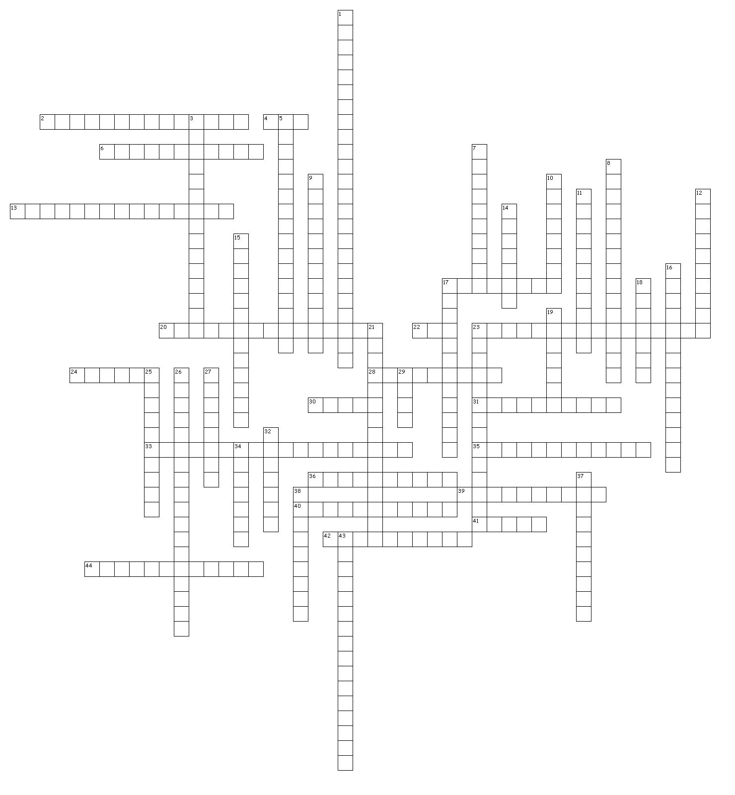

**UNIT 3 REVISION**

Across

2. is an abiotic or biotic factor that restricts the number of individuals in a population

4. the amount of chemical energy, typically expressed as carbon biomass, that primary producers create in a given length of time

6. results when organisms struggle to survive in a habitat with limited resources

13. the role and space that an organism fills in an ecosystem, including all its interactions with the biotic and abiotic factors of its environment

17. the ultimate source of energy for organisms found in an ecosystem

20. a plant or animal that plays a unique and crucial role in the way an ecosystem functions

22. the energy stored as biomass (gross production – energy lost as heat in respiration)

23. the area of each step is proportional to the numbers of organisms present at each trophic level

24. factors that are the living parts of the ecosystem

28. consists of all the plants and animals that occupy a particular area

30. a group of organisms that consists of a common ancestor and all its lineal descendants

31. a process by which communities of plants and animals colonise an area and then, over time, are replaced by other, more varied organisms

33. the process of identifying areas within an overall habitat, which may be very different from each other and which need to be sampled separately

35. the position occupied by a group of organisms in a food chain

36. dissolving of limestone deposits by rain returns carbon atoms to atmospheric carbon dioxide

39. tends to maximize population size and operates in populations living at a density near the limit imposed by their resources (carrying capacity, K)

40. a growth pattern (J curve) that occurs in an ideal, unlimited environment

41. stages of succession

42. composed of varied habitats

44. includes the diversity of species and ecosystems

Down

1. this can be hierarchical and based on different levels of similarity of physical features, methods of reproduction and molecular sequences

3. final stage of succession

5. the area of each step is proportional to the to total dry mass of all the organisms present in that trophic level.

7. the burning of fossil fuels releases stored carbon dioxide into the atmosphere

8. a measure of the relative abundance of the different species

9. the index used to estimate population size

10. a sampling line over an environmental gradient

11. when living organisms (plants, animals and decomposers) do this they release carbon dioxide into the atmosphere

12. organisms that harness the energy of the sun to make biomass

14. factors that are the non-living parts of the ecosystem

15. when complex, carbon compounds in dead organisms, urine and faeces are broken down into simpler carbon compounds by bacteria or fungi

16. features include ability to fixate nitrogen, tolerance to extreme conditions, rapid germination of seeds, ability to photosynthesise

17. can be reduced by calibrating equipment

18. type of succession where plants grow where none have grown before, starting from bare rock or water

19. the Sun’s light energy is captured and used by green plants and algae during photosynthesis, to make this

21. the number of different species in an ecosystem

23. process where plants absorb carbon dioxide from the atmosphere and form it into sugar, starch and other organic compounds. This is the only process in the carbon cycle that decreases the level of carbon dioxide in the atmosphere.

25. assumptions include commonly ancestry, bifurcation and physical change

26. these are assumed to accumulate mutations at a constant rate over time, and therefore provide a method for dating divergence

27. a growth pattern (S curve) that occurs when environmental pressures slow the rate of growth

29. an example of an interspecific hybrid that does not produce fertile offspring

32. moves carbon in the form of biological molecules along the food chain

34. a complex network of inter-related food chains

37. depends on the number of individuals added to the population from births and immigration, minus the number lost through deaths and emigration

38. plants grow where there has been a previous population that were destroyed by something like fire

43. the size of the population that can be supported indefinitely on the available resources and services of that ecosystem