Biology Unit 3: Biodiversity & the interconnectedness of Life Revision Guide
Subject matter |  | Where can I find this in my notes? | Quick Notes about this subject matter | Rate my learning | What I need to revise further…
Biodiversity | - recognise that biodiversity includes the diversity of species and ecosystems |  |  | .
 | - determine diversity of species using measures such as species richness, evenness (relative species abundance), percentage cover, percentage frequency and Simpson’s diversity index |  | 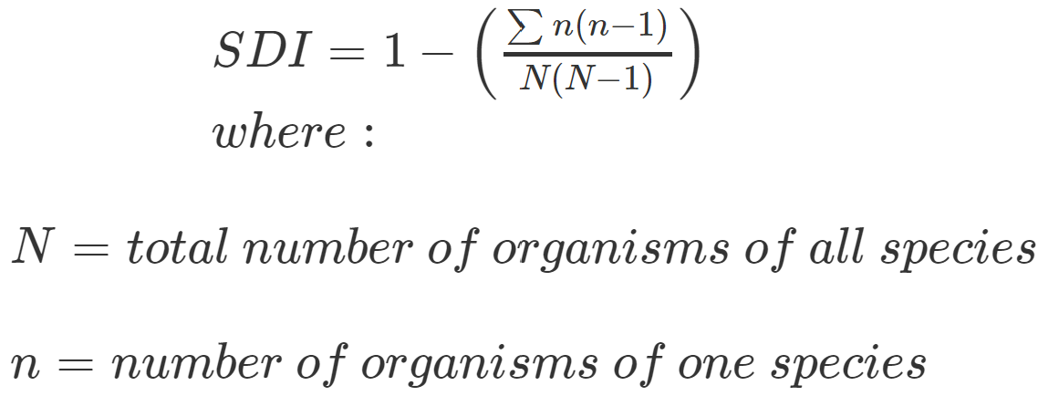 | .
 | - explain how environmental factors limit the distribution and abundance of species in an ecosystem. |  |  | .
 | - Mandatory practical: Determine species diversity of a group of organisms based on a given index. |  |  | .
 | - Suggested practical: Measure abiotic factors in the classroom using field samples (e.g. pH, nitrogen nutrients, salinity, carbonates, turbidity). |  |  | .
 | - Suggested practical: Measure abiotic factors in the field (e.g. dissolved oxygen, light, temperature, wind speed, infiltration rate). |  |  | .
Classification processes | - Recognize that biological classification can be hierarchical and based on different levels of similarity of physical features, methods of reproduction and molecular sequences |  |  | .
 | - describe the classification systems for  - similarity of physical features (the Linnaean system)  - methods of reproduction (asexual, sexual — K and r selection)  - molecular sequences (molecular phylogeny — also called cladistics) |  |  | .
 | - define the term clade |  | Clade: a group of organisms that consists of a common ancestor and all its lineal descendants
 | - recall that common assumptions of cladistics include a common ancestry, bifurcation and physical change
 | - interpret cladograms to infer the evolutionary relatedness between groups of organisms
 | - analyse data from molecular sequences to infer species evolutionary relatedness
 | - recognise the need for multiple definitions of species
 | - identify one example of an interspecific hybrid that does not produce fertile offspring (e.g. mule, Equus mulus)
 | - explain the classification of organisms according to the following species interactions: predation, competition, symbiosis and disease
 | - understand that ecosystems are composed of varied habitats (microhabitat to ecoregion)
 | - interpret data to classify and name an ecosystem
 | - explain how the process of classifying ecosystems is an important step towards effective ecosystem management (consider old-growth forests, productive soils and coral reefs)
- describe the process of stratified sampling in terms of
  - purpose (estimating population, density, distribution, environmental gradients and profiles, zonation, stratification)
  - site selection
  - choice of ecological surveying technique (quadrats, transects)
  - minimizing bias (size and number of samples, random-number generators, counting criteria, calibrating equipment and noting associated precision)
  - methods of data presentation and analysis.
 | - Mandatory practical: Use the process of stratified sampling to collect and analyse primary biotic and abiotic field data to classify an ecosystem.
Functioning Ecosystems | - sequence and explain the transfer and transformation of solar energy into biomass as it flows through biotic components of an ecosystem, including  - converting light to chemical energy  - producing biomass and interacting with components of the carbon cycle
- analyse and calculate energy transfer (food chains, webs and pyramids) and transformations within ecosystems, including
  - loss of energy through radiation, reflection and absorption
  - efficiencies of energy transfer from one trophic level to another
  - biomass
 | - construct and analyse simple energy-flow diagrams illustrating the movement of energy through ecosystems, including the productivity (gross and net) of the various trophic levels
 | - describe the transfer and transformation of matter as it cycles through ecosystems (water, carbon and nitrogen)
 | - define ecological niche in terms of habitat, feeding relationships and interactions with other species |  | Ecological niche: the role and space that an organism fills in an ecosystem, including all its interactions with the biotic and abiotic factors of its environment
 | - understand the competitive exclusion principle
 | - analyse data to identify species (including microorganisms) or populations occupying an ecological niche
 | - define keystone species and understand the critical role they play in maintaining the structure of a community |  | Keystone species: a plant or animal that plays a unique and crucial role in the way an ecosystem functions
 | - analyse data (from an Australian ecosystem) to identify a keystone species and predict the outcomes of removing the species from an ecosystem.
- Suggested practical: Study the abundance of each trophic level in a simple food chain.
- Suggested practical: Measure the wet biomass of producer samples.
- Suggested practical: Test the competitive exclusion principle hypothesis by studying vertical zonation on a tree.
- Suggested practical: Carry out a longitudinal study of a keystone species and relevant ecological interactions.
Population Ecology | - define the term carrying capacity |  | Carrying capacity: in Biology, the size of the population that can be supported indefinitely on the available resources and services of that ecosystem
 | - explain why the carrying capacity of a population is determined by limiting factors (biotic and abiotic)
 | - calculate population growth rate and change (using birth, death, immigration and emigration data)
 | - use the Lincoln Index to estimate population size from secondary or primary data |  | 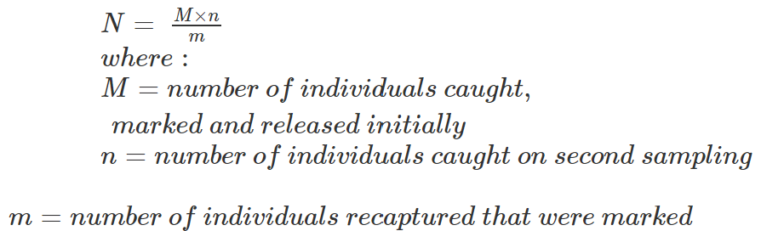
 | - analyse population growth data to determine the mode (exponential growth J-curve, logistic growth S-curve) of population growth
 | - discuss the effect of changes within population-limiting factors on the carrying capacity of the ecosystem.
- Suggested practical: Conduct an abundance and distribution study, including abiotic and biotic factors.
- Suggested practical: Measure the population of microorganisms in Petri dishes to observe carrying capacity.
Changing Ecosystems | - explain the concept of ecological succession (refer to pioneer and climax communities and seres)
 | - differentiate between the two main modes of succession: primary and secondar
 | - identify the features of pioneer species (ability to fixate nitrogen, tolerance to extreme conditions, rapid germination of seeds, ability to photosynthesise) that make them effective colonisers
 | - analyse data from the fossil record to observe past ecosystems and changes in biotic and abiotic components
 | - analyse ecological data to predict temporal and spatial successional changes
 | - predict the impact of human activity on the reduction of biodiversity and on the magnitude, duration and speed of ecosystem change
 | - Mandatory practical: Select and appraise an ecological surveying technique to analyse species diversity between two spatially variant ecosystems of the same classification (e.g. a disturbed and undisturbed dry sclerophyll forest).

Biology Unit 4: Heredity & Continuity of Life Revision Guide
Subject matter |  | Oxford Textbook Chapter Reference | Student Notebook  (Where can I find this in my notes?) | Quick Notes about this subject matter | Rate my learning  (Student Use Only) | What I need to revise further (Student Use)
Topic 1: DNA, Genes and the continuity of life
DNA structure and replication | - understand that deoxyribonucleic acid (DNA) is a double-stranded molecule that occurs bound to proteins (histones) in chromosomes in the nucleus, and as unbound circular DNA in the cytosol of prokaryotes, and in the mitochondria and chloroplasts of eukaryotic cells |  |  |  | .
 | - recall the structure of DNA, including  - nucleotide composition  - complementary base pairing  - weak, base-specific hydrogen bonds between DNA strands |  |  |  | .
 | - explain the role of helicase (in terms of unwinding the double helix and separation of the strands) and DNA polymerase (in terms of formation of the new complementary strands) in the process of DNA replication. Reference should be made to the direction of replication
 | - Suggested practical: Extract DNA from strawberries, kiwifruit or wheat germ.
Cellular replication and variation | - within the process of meiosis I and II  - recognise the role of homologous chromosomes  - describe the processes of crossing over and recombination and demonstrate how they contribute to genetic variation  - compare and contrast the process of spermatogenesis and oogenesis (with reference to haploid and diploid cells).
 | - demonstrate how the process of independent assortment and random fertilisation alter the variations in the genotype of offspring.
Gene expression | - define the terms genome and gene |  |  | - Genome: all the genetic material in the chromosomes of an organism, including its genes and DNA sequences  - Gene: region/s of DNA that are made up of nucleotides; the molecular unit of heredity
 | - understand that genes include ‘coding’ (exons) and ‘noncoding’ DNA (which includes a variety of transcribed proteins: functional RNA (i.e. tRNA), centromeres, telomeres and introns. Recognise that many functions of ‘noncoding’ DNA are yet to be determined)
- explain the process of protein synthesis in terms of
  - transcription of a gene into messenger RNA in the nucleus
  - translation of mRNA into an amino acid sequence at the ribosome (refer to transfer RNA, codons and anticodons)
 | - recognise that the purpose of gene expression is to synthesise a functional gene product (protein or functional RNA); that the process can be regulated and is used by all known life
- identify that there are factors that regulate the phenotypic expression of genes
  - during transcription and translation (proteins that bind to specific DNA sequences)
  - through the products of other genes
  - via environmental exposure (consider the twin methodology in epigenetic studies)
 | - recognise that differential gene expression, controlled by transcription factors, regulates cell differentiation for tissue formation and morphology
 | - recall an example of a transcription factor gene that regulates morphology (HOX transcription factor family) and cell differentiation (sex-determining region Y).
Mutations | - identify how mutations in genes and chromosomes can result from errors in  - DNA replication (point and frameshift mutation)  - cell division (non-disjunction)  - damage by mutagens (physical, including UV radiation, ionising radiation and heat and chemical)
 | - explain how non-disjunction leads to aneuploidy |  |  | - Examples of aneuploidy could include trisomy 21.
 | - use a human karyotype to identify ploidy changes and predict a genetic disorder from given data
 | - describe how inherited mutations can alter the variations in the genotype of offspring.
Inheritance | - predict frequencies of genotypes and phenotypes using data from probability models (including frequency histograms and Punnett squares) and by taking into consideration patterns of inheritance for the following types of alleles: autosomal dominant, sex linked and multiple
 | - define polygenic inheritance and predict frequencies of genotypes and phenotypes for using three of the possible alleles.
Biotechnology | - describe the process of making recombinant DNA  - isolation of DNA, cutting of DNA (restriction enzymes)  - insertion of DNA fragment (plasmid vector)  - joining of DNA (DNA ligase)  - amplification of recombinant DNA (bacterial transformation)
 | - recognise the applications of DNA sequencing to map species’ genomes and DNA profiling to identify unique genetic information
 | - explain the purpose of polymerase chain reaction (PCR) and gel electrophoresis
 | - appraise data from an outcome of a current genetic biotechnology technique to determine its success rate.
- Suggested practical: Perform a bacterial transformation.
https://dnalc.cshl.edu/resources/dnatoday/2020-virtual-lab-bt.html
 | - Suggested practical: Interpret DNA profiles from gel electrophoresis (either laboratory or computer simulation based).
Topic 2: Continuity of life on Earth
Evolution | - define the terms evolution, microevolution and  macroevolution |  |  | - Evolution: change in the genetic composition of a population during successive generations, which may result in the development of new species  - Macroevolution: the variation of allele frequencies at or above the level of species over geological time, resulting in the divergence of taxonomic groups, in which the descendant is in a different taxonomic group to the ancestor  - Microevolution: small-scale variation of allele frequencies within a species or population, in which the descendant is of the same taxonomic group as the ancestor
 | - determine episodes of evolutionary radiation and mass extinctions from an evolutionary timescale of life on Earth (approximately 3.5 billion years)
 | - interpret data (i.e. degree of DNA similarity) to reveal phylogenetic relationships with an understanding that comparative genomics involves the comparison of genomic features to provide evidence for the theory of evolution
Natural selection and microevolution | - recognise natural selection occurs when the pressures of environmental selection confer a selective advantage on a specific phenotype to enhance its survival (viability) and reproduction (fecundity)
 | - identify that the selection of allele frequency in a gene pool can be positive or negative
 | - interpret data and describe the three main types of phenotypic selection: stabilising, directional and disruptive
 | - explain microevolutionary change through the main processes of mutation, gene flow and genetic drift
 | - Mandatory practical: Analyse genotypic changes for a selective pressure in a gene pool (modelling can be based on laboratory work or computer simulation).
Speciation and macroevolution | - recall that speciation and macroevolutionary changes result from an accumulation of microevolutionary changes over time
 | - identify that diversification between species can follow one of four patterns: divergent, convergent, parallel and coevolution
 | - describe the modes of speciation: allopatric, sympatric, parapatric
 | - understand that the different mechanisms of isolation — geographic (including environmental disasters, habitat fragmentation), reproductive, spatial, and temporal — influence gene flow
 | - explain how populations with reduced genetic diversity (i.e. those affected by population bottlenecks) face an increased risk of extinction
 | - interpret gene flow and allele frequency data from different populations in order to determine speciation.

