

**Year 12 Biology**

Term 1 Unit 3: Knowledge Exam MARKSCHEME

Name: __________________________

**Section 1**

### Instructions

* Answer all questions in this book.

### QUESTION 1

In 1978, a population of a migratory shore bird was estimated at 90 000 individuals. An analysis of monitoring data in 2018 showed the population is now at 50 000. The change in population growth for this species is

1. –29%
2. –44%
3. –55%
4. –80%

### QUESTION 2

Which feature makes pioneer species effective colonisers?

1. large seeds
2. slow-growth rate
3. shade-tolerant seedlings
4. ability to fixate nitrogen

### QUESTION 3

In rare circumstances, a male false killer whale (*Pseudorca crassidens*) breeds with a female common bottlenose dolphin (*Tursiops truncatus*) and produces live offspring called ‘wholphins’.

For a biologist to conclude that the false killer whale and the common bottlenose dolphin are the same species, the resulting offspring would need to

1. be physically similar to both parent organisms
2. be unable to produce gametes
3. be able to produce offspring with another false killer whale or common bottlenose dolphin
4. inherit half of their chromosomes from the common bottlenose dolphin

### QUESTION 4

A keystone species can be correctly defined as:

1. a species that is critically endangered
2. a species chosen to raise support for biodiversity conservation in a chosen place.
3. a species selected when making decisions about conservation
4. a species that holds a unique and crucial role in the way an ecosystem functions by maintaining the balance of organisms.

### QUESTION 5

This figure shows an energy pyramid for a hypothetical ecosystem.

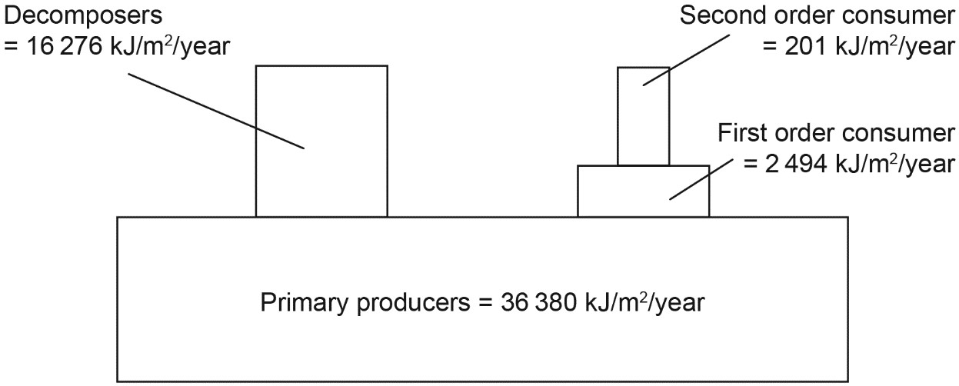

The trophic level transfer efficiency of primary producers to herbivores in this situation would be

1. 0.6%.
2. 6.9%.
3. 7.4%.
4. 44.7%.

### QUESTION 6

Biodiversity is recognised as the total variety of

1. species interrelationships, biotic and abiotic factors.
2. communities of organisms occupying major habitats.
3. regions of surface and atmosphere occupied by organisms.
4. organisms, habitats, communities and ecological processes.

### QUESTION 7

Which of the figures below represents a logistic population growth of a species over time?

### 



### QUESTION 8

White-breasted nuthatches and Downy woodpeckers both eat insects that hide in the furrows of bark in hardwood trees. The Downy woodpecker searches for insects by hunting from the bottom of the tree trunk to the top, while the White-breasted nuthatch searches from the top of the trunk down. These hunting behaviors best illustrate which of the following ecological concepts?

1. Competitive exclusion
2. Character displacement
3. Resource partitioning
4. Keystone species

### QUESTION 9

The figure below shows an energy diagram for a freshwater lake ecosystem.

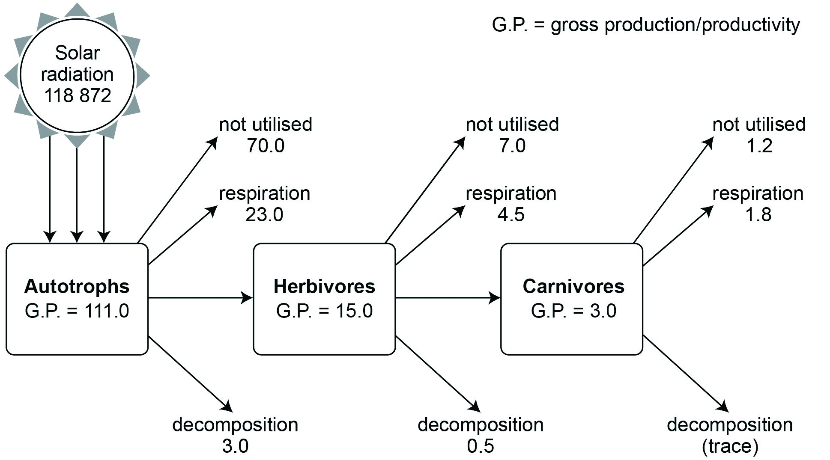

The percentage of energy transferred to herbivores is

(A) 86.5%.

(B) 20.0%.

(C) 13.5%.

(D) 0.01%.

### QUESTION 10

The progressive series of changes that eventually produce a climax community on what was once a bare rocky island is an example of

1. Primary succession
2. Speciative succession
3. Climatic succession
4. Secondary succession

### QUESTION 11

An ecological niche is defined as the role and space that an organism fills in an ecosystem, including all its interactions with the

1. biotic and abiotic factors of its environment.
2. available resources and services of its environment.
3. other species in its environment that it outcompetes.
4. individuals immigrating and emigrating in its environment.

Questions 12 and 13 relate to the information below.

The following phylogenetic tree shows the relationships among the major groups of plants and the points in their evolution at which particular characteristics arose. The time frame is in millions of years ago (MYA).

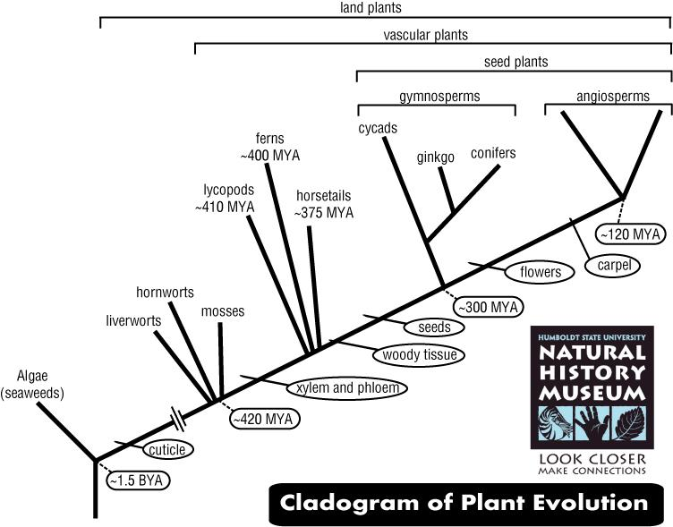

### QUESTION 12

The phylogenetic tree indicates that

1. angiosperms evolved from mosses and ferns
2. gymnosperms evolved from angiosperms
3. liverworts, hornworts and mosses form a single related group of plants
4. cycads, ginkgoes and conifers form a single related group of plants.

### QUESTION 13

The phylogenetic tree also indicates that

1. seeds evolved after flowers
2. woody tissue evolved after xylem and phloem
3. cycads have woody tissue and flowers
4. cuticle is present in ferns but not in mosses

### QUESTION 14

The following phylogenetic tree shows the evolutionary relationships among eight plant species.

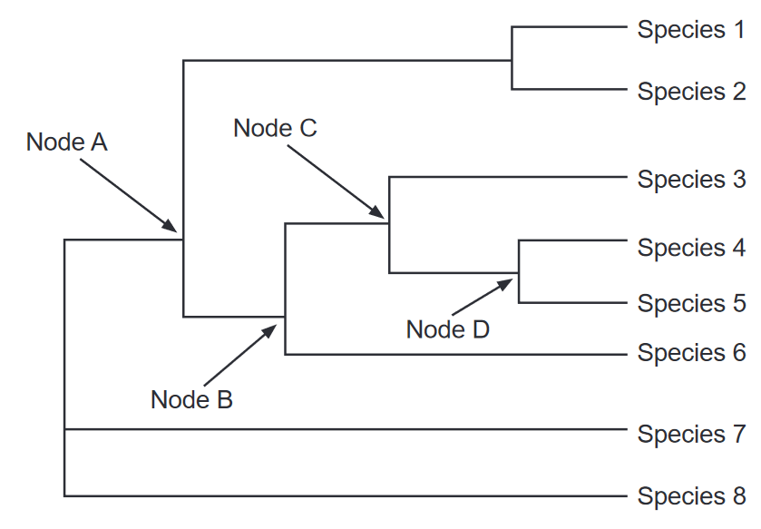

Which node (branch point) in the phylogenetic tree represents the most recent common ancestor of species 3, 4, 5 and 6?

(A) Node A

(B) Node B

(C) Node C

(D) Node D

### QUESTION 15

The principle of competitive exclusion states that

1. two species cannot coexist in the same habitat.
2. competition between two species always causes extinction or emigration of one species.
3. two species that have exactly the same niche cannot coexist in a community.
4. two species will stop reproducing until one species leaves the habitat.

### QUESTION 19

Two organisms live in close physical association, typically to the advantage of both. Which of the following is the correct species interaction to describe this relationship?

1. competition
2. symbiosis
3. predation
4. disease

### QUESTION 20

The table below shows the classification of some Australian plants.

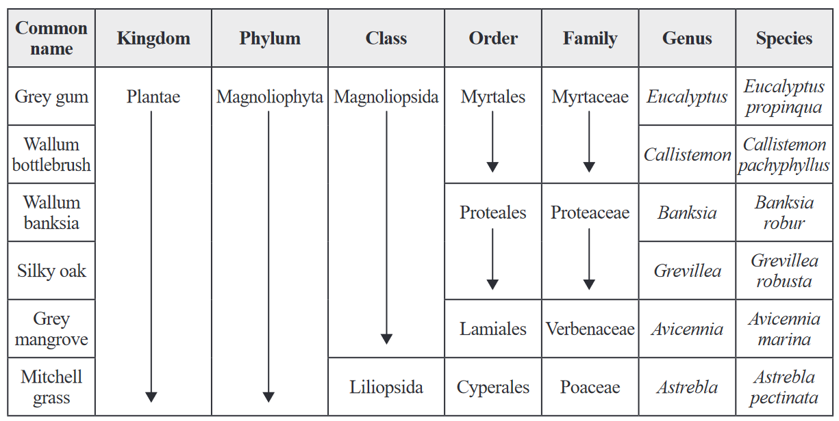

Identify the plant that is most different from the others.

(A) *Eucalyptus propinqua*

(B) *Astrebla pectinata*

(C) *Avicennia marina*

(D) *Grevillea robusta*

### QUESTION 21

In a terrestrial ecosystem, the trophic level that would contain the largest biomass would be the

1. Producers
2. Primary consumers
3. Secondary consumers
4. Tertiary consumers

### QUESTION 22

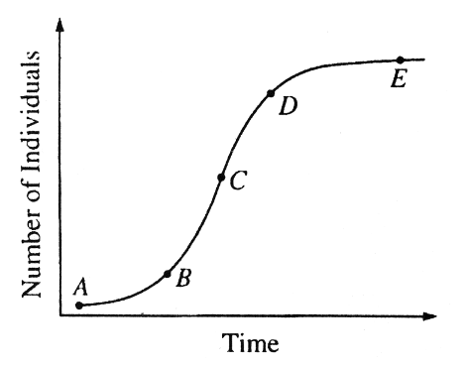Which point on the curve in the diagram best represents the carrying capacity of the environment for the population shown.

1. A
2. B
3. C
4. D
5. E

Questions 23 and 24 relate to the information below.

This figure depicts an experiment where concrete blocks were placed in the ocean and marine organisms were allowed to colonize for various lengths of time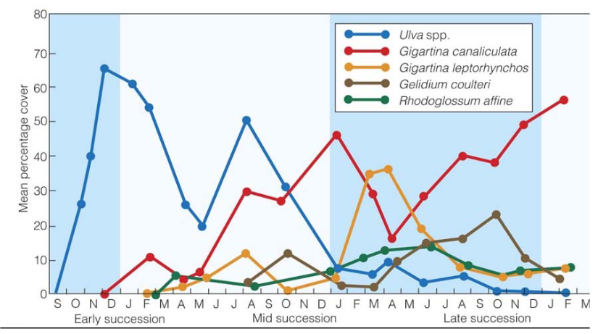

### QUESTION 23

This experiment is assessing:

1. Primary succession
2. Secondary succession

### QUESTION 24

Identify the r-selected species in this community

1. *Ulva* spp.
2. *Gigartina canaliculata*
3. *Gigartina leptorhynchos*
4. *Gelidium coulteri*
5. *Rhodoglossum affine*

**Section 2**

* Answer all questions in this book.

### QUESTION 25

Ecologists were interested in studying organisms that were found in different areas of a property. The map is shown below:

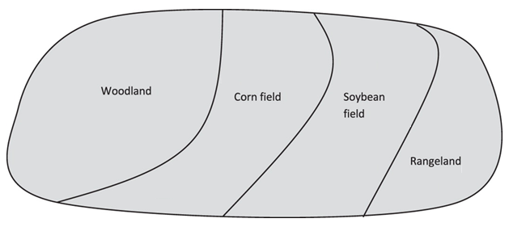

Describe how ecologists could use process of stratified sampling to undertake such a study. **(6 marks)**

**Purpose**: Assess the invertebrate species richness, determine species richness/evenness in each type of habitat; any other valid variable.

Dependent variable: Invertebrate species richness in each habitat; any other valid variable.

**Site selection**: Clearly marked out and the location is accurately recorded so future surveys can take place.

**Ecological surveying technique**: Random sampling with quadrats; sweep net to collect animals

**Minimising bias**: Suitable number of samples, consistent counting criteria, use of random number tables.

**Presenting data**: This will depend on what you chose to measure, but can be presented in graphs or transect line or profile diagrams.

**Analysing data**: Data will be analysed using standard error and standard deviation.

### QUESTION 26

Describe the nitrogen cycle. **(15 marks)** *Dotpoints welcome!*

1. Nitrogen gas in air/atmosphere
2. Required for amino acids/protein/ nucleic acids
3. Assimilated in plants and then converted to biomass in animals
4. Nitrogen fixation by lightning
5. convert nitrogen to nitrates
6. Nitrogen fixing bacteria in root nodules (of legumes) *and*
7. Free living nitrogen fixing bacteria in the soil
8. Convert nitrogen gas to ammonia/ammonium, then enzyme action converts to nitrates
9. Urea, egested material and decomposing matter contains N compounds
10. and is broken down by saprophytic bacteria/decomposers.
11. Results in nitrogen being returned to the soil as ammonia (NH3) or ammonium (NH4+)
12. in the process of ammonification
13. Nitrifying bacteria convert ammonia (NH3) and ammonium (NH4+) to nitrites (NO2-) and then nitrates (NO3-)
14. in the process of nitrification.
15. Denitrifying convert nitrates to nitrogen
16. in waterlogged/anaerobic conditions
17. in the process of denitrification.