**Unit 3, Topic 1 Practice Questions**

1. Describe a productive soil. (1 mark)

______________________________________________________________________________________________________________________________________________________________

1. Explain how the process of classifying ecosystems is an important step towards effective ecosystem management of productive soils. (4 marks)

_________________________________________________________________________________________________________________________________________________________________________________________________________________________________________________________________________________________________________________________________________________________________________________________________________________________________________________________________________________________________________________________________________________________________________

1. Define the term clade. (1 mark)

______________________________________________________________________________________________________________________________________________________________

1. Identify an example of an interspecific hybrid. (1 mark)

_______________________________________________________________________________

1. Explain why environmental factors limit the distribution and abundance of species in an ecosystem. (2 marks)

____________________________________________________________________________________________________________________________________________________________________________________________________________________________________________________________________________________________________________________________

1. Recall one common assumption of cladistics. (1 mark)

_______________________________________________________________________________

1. Describe commensalism. (1 mark)

_______________________________________________________________________________

1. Name one example of commensalism. (1 mark)

_______________________________________________________________________________

1. a. The table below shows data collected from a study carried out to estimate the species diversity of a range of fish species in a tidal pool ecosystem.

|  |  |
| --- | --- |
| Fish species | Number of individuals |
| *Dalefish* | 44 |
| *Baggifish* | 32 |
| *Coolfish* | 14 |
| *Glenfish* | 11 |
| *Halfish* | 17 |
| *Thomfish* | 2 |

Use the following equation to calculate the SDI of the tidal pool ecosystem. (1 mark)

Give your answer to 2dp.

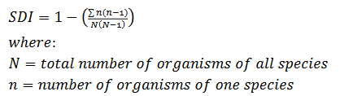

Answer: ___________________

1. From the given information above, determine the species richness (D) for the tidal pool ecosystem. Use the following equation and give your answer to 2dp.

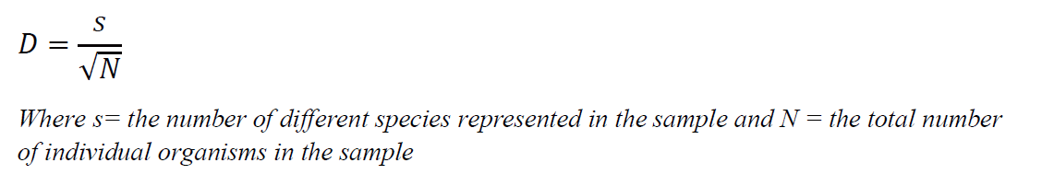

Answer: ___________________

1. Describe the Linnaean system of classifying organisms. (3 marks)

_____________________________________________________________________________________________________________________________________________________________________________________________________________________________________________

1. Cytochrome C is a protein that consists of 104 amino acids. Many of these 104 sites on Cytochrome C contain the same amino acid across a large range of organisms. There are, however, some differences at certain sites. It is hypothesised that different organisms, all containing Cytochrome C proteins, descended from a primitive microbe that lived over 2 billion years ago.

The table below uses the three-letter codes for various amino acids found at specific sites for each organism.

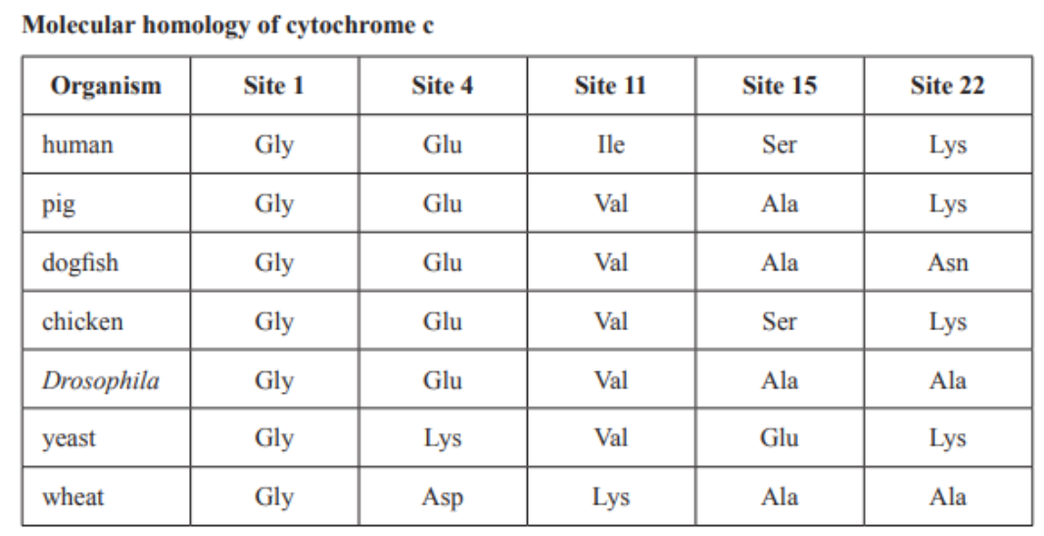

Using only the data for the molecular homology of Cytochrome C, which one of the following organisms is most closely related to the dogfish? (1 mark)

1. Drosophila
2. Chicken
3. Human
4. Yeast
5. Identify the correct convention for naming a Dalefish. (1 mark)
6. Biologo daleii
7. biologo daleii
8. *Biologo daleii*
9. Biologo Daleii
10. The diagrams below represent two separate communities. Different shapes represent different species. (1 mark)

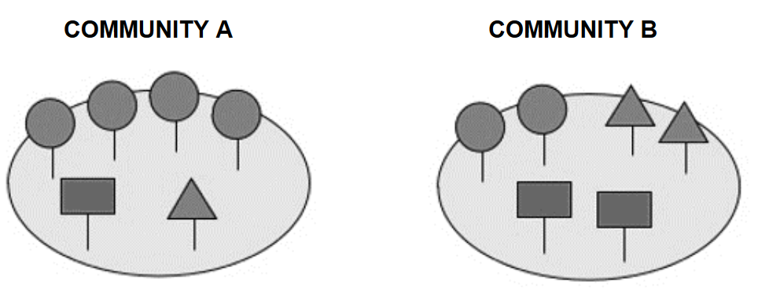

With respect to the two communities:

1. Community A has a higher species richness than Community B
2. Community A has a higher species evenness than Community B
3. Community A has a lower species richness than Community B
4. Community A has a lower species evenness than Community B
5. The phylogenetic tree below shows the evolution of plants.

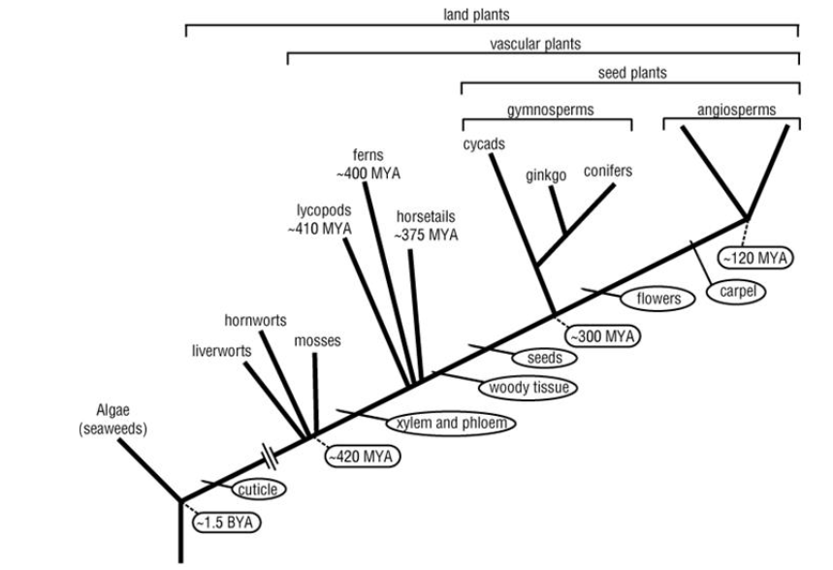

The phylogenetic tree indicates that: (1 mark)

1. Seeds evolved after flowers
2. Woody tissue evolved after xylem and phloem
3. Cycads have woody tissue and flowers
4. Cuticle is present in ferns but not mosses
5. Recall what is assumed to accumulate mutations at a constant rate over time. (1 mark)

_______________________________________________________________________________

1. a. The Holdridge system can be used to classify an ecosystem:

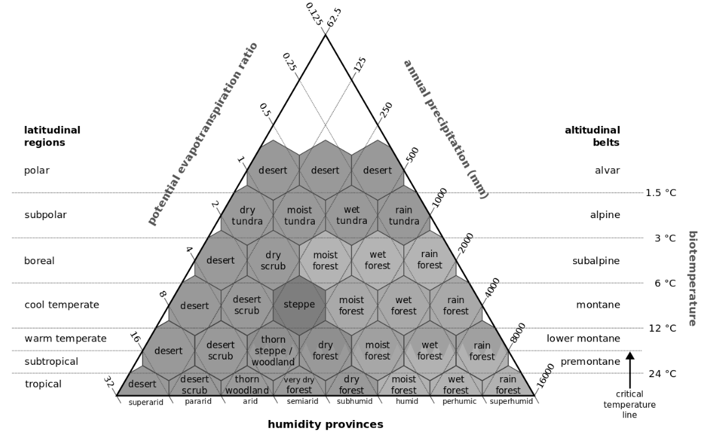

The potential evapotranspiration ratio of a subtropical rainforest would be: (1 mark)

1. Between 16 and 32
2. Between 8 and 16
3. Between 0.125 and 0.25
4. Between 4000 and 8000

b. Using the Holdridge system, classify an ecosystem with a PER of 2.6 and an annual precipitation of 65. (1 mark)

_______________________________________________________________________________

17. The wholphin is an example of: (1 mark)

1. An r-select strategist
2. An interspecific hybrid
3. A keystone species
4. A pioneer species
5. Contrast r and K reproductive strategies. (4 marks)

__________________________________________________________________________________________________________________________________________________________________________________________________________________________________________________________________________________________________________________________________________________________________________________________________________________________________________________________________________________________

1. Describe ammensalism. (1 mark)

_______________________________________________________________________________

1. Name one example of ammensalism. (1 mark)

_______________________________________________________________________________

1. Below is part of the phylogenetic tree for the Felidae.

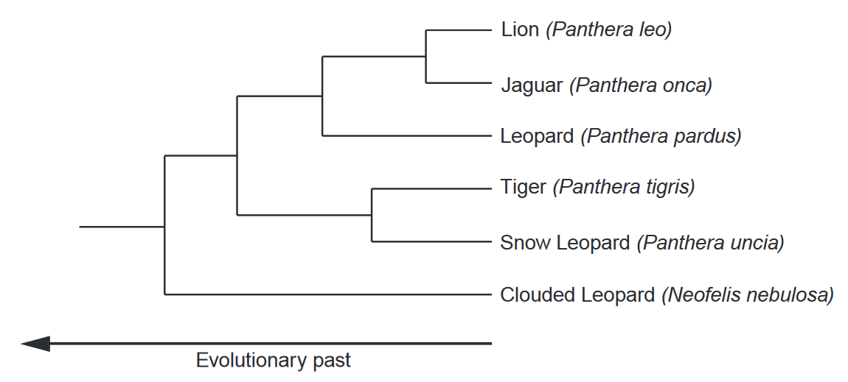

Using evidence from the diagram, state which two cat species are likely to be most closely related. (1 mark)

_______________________________________________________________________________

1. Light is an environmental factor that affects the growth of eucalyptus trees. Give two other environmental factors that affect the growth of dandelion plants. (2 marks)

1._____________________________________________________________________________

2._____________________________________________________________________________

1. The photo shows a ring-tailed lemur.

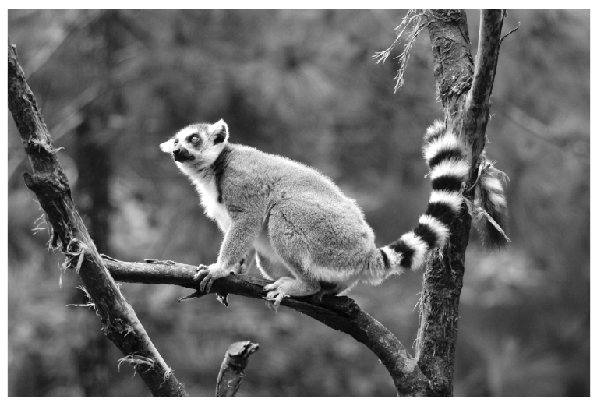

The table shows part of the classification of the ring-tailed lemur.

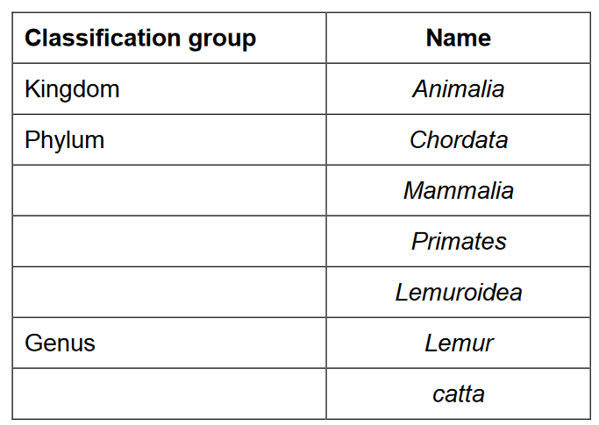

1. Complete the table to give the names of the missing classification groups. (1 mark)
2. Give the binomial name of the ring-tailed lemur. Use the information from the table. (1 mark)

_______________________________________________________________________________